PACMAN GAME PROJECT REPORT
1. Introduction
Pac man is one of the games that was played in early days when game were just getting started . IN this game there is usually an anime that is basically the host and the player controls it and save it from obstacles and other anime which are usually called ghost
The purpose of this project is to develop a console-based simulation of Pacman that demonstrates basic game mechanics such as movement, collision detection, and grid navigation.



2. Objectives
The main objectives of this project are:
- To design and implement a grid-based Pacman game
- To implement player movement using user input
- To handle boundary and obstacle conditions effectively

3. System Design and Working
3.1 Grid Representation
The game is shown by a grid which id 2D. The grid contains:
- Empty spaces where Pacman can move
- These spaces have dots which have score.
- Obstacles that block movement
- The current position of Pacman

3.2 Player (Pacman) Movement
The player controls Pacman using keyboard inputs:
- W → Move Up
- S → Move Down
- A → Move Left
- D → Move Right
- Whenever the new key is pressed that checks whether that movement will be valid or not and the updates the grid


3.3 Checking Boundary
The program ensures that Pacman does not move outside the grid. If the player attempts to move beyond the grid boundaries, the move is restricted.

3.4 Handling Obstacle
Through programming the positions of obstacles are fixed so if the user tries to move the host at the position of obstacle it cant move

3.5 Game Loop
The game runs continuously using a loop that performs the following steps:
- Display the current state of the grid
- Take input from the user
- Process the movement
- Update Pacman’s position
- Refresh the grid display
The game will end only if :
- Ghost eats animi
- Host successfully eats all the dots without being caught by ghost

4. Code Structure

1. Pacman Class
This class handles the player character. It contains the position of Pacman, movement logic, and score calculation when dots are collected.
2. Ghost Class
This class controls the enemy (ghost). It manages the ghost’s position and random movement within the grid while avoiding obstacles.
3. Main Class
This class manages the overall game flow. It includes the game loop, user input handling, grid display, and checks for win or loss conditions.
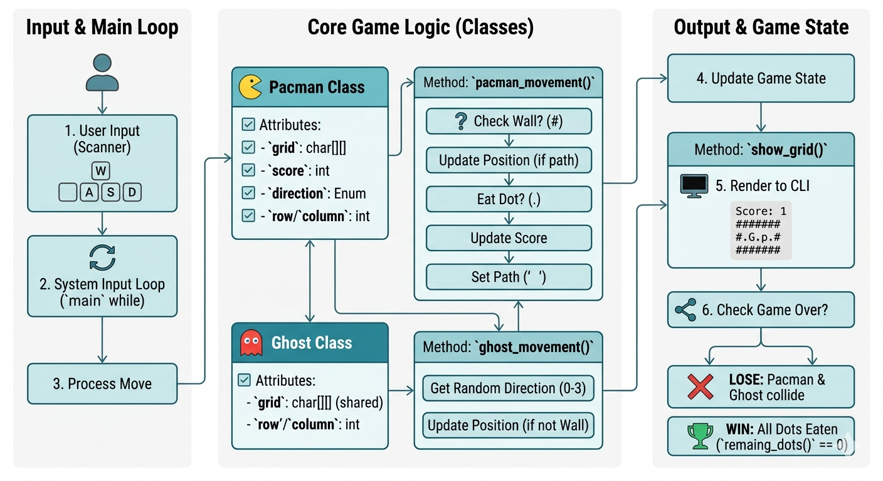

5. Features of the Project
- Simple and interactive gameplay
- Grid-based movement system
- Real-time user input handling
- Obstacle detection and restriction
- Clear and structured output display
- Easy-to-understand implementation

6. Conclusion
In conclusion, the Pacman project is a successful implementation of a basic grid-based game using Java. It demonstrates fundamental programming concepts such as arrays, loops, conditionals, and object-oriented design.

NAME = AMINA ZAHID
ROLL NUMBER = 2025-CYS-10

